Tracking and Managing Experiments with MLFlow

1.0 Introduction: Establishing a Foundation for Reproducible Machine Learning
In any complex machine learning endeavor, such as our flight delay prediction project, managing the lifecycle of experiments is a critical challenge. Without a systematic approach, our development process descends into a costly mire of disconnected scripts and untraceable model artifacts, wasting compute resources and making it impossible to answer simple questions like, "Which experiment produced our best-performing model?" The strategic implementation of a robust tracking system is therefore not just a convenience, but a necessity for building reliable and maintainable machine learning systems. Our goal is to move beyond ad-hoc experiment management to a systematic MLOps workflow that ensures complete traceability, comparability, and reliability for every model we build.
To achieve this, we have chosen MLFlow as our centralized solution for experiment tracking and management. Integrated directly into our Spark-based data pipeline, MLFlow provides the structured framework needed to log, query, and visualize the entire lifecycle of our machine learning experiments. The following sections detail our specific MLFlow integration architecture, our standardized tracking methodology, and the comprehensive set of data points we capture for each experimental run.

2.0 MLFlow Integration Architecture
We architected our MLFlow integration to provide a consistent and seamless tracking experience across different working environments, from local development on a single machine to large-scale jobs on a production cluster. This dual-environment design ensures that all experimental results, whether from rapid prototyping or official training runs, are captured in a standardized manner.

2.1 Docker-Based Environment
For local development and testing, we utilize a self-contained environment managed by docker-compose. Within this setup, MLFlow runs as a dedicated service container, ensuring isolation and portability.
Based on the docker-compose.yml configuration, the mlflow-server service uses the official ghcr.io/mlflow/mlflow:v3.4.0 image. Its key configurations are:
- Backend Store: An SQLite database, located at sqlite:///mlflow/mlflow.db. This database file resides in the ../work/mlflow directory on the host machine, which is volume-mapped into the container, ensuring metadata persistence across container restarts.
- Artifact Store: The local filesystem, mapped to /mlflow/artifacts within the container, serves as the artifact store. This is where all large outputs, such as trained model files, datasets, and generated plots, are saved.
- Accessibility: The MLFlow server is accessible to all other services within the Docker network at the address http://mlflow-server:5000.
This Dockerized approach provides an easily reproducible and self-contained environment, allowing any team member to spin up the entire Spark and MLFlow stack with a single command for local experimentation.

2.2 Spark Cluster Integration
To enable our distributed Spark jobs to communicate with the MLFlow server, we have built a custom Spark image. As defined in Dockerfile.spark-mlflow, this image extends the base Bitnami Spark image and installs the mlflow==3.4.0 Python client library, along with visualization libraries like matplotlib and seaborn.
The strategic value of this custom image is to empower every Spark job with native MLFlow capabilities. By baking the client libraries directly into the execution environment, we eliminate boilerplate and ensure that any application or notebook session can seamlessly log parameters, metrics, and artifacts to a unified tracking server.

2.3 Deployment Environments
Our MLFlow architecture is deployed across two primary environments to support the full development lifecycle:
- Local Development: As part of the docker-compose stack, this instance is ideal for rapid prototyping, debugging, and individual experimentation.
- Lamsade Cluster: A shared, persistent installation of MLFlow serves as the central repository for larger, official experiments. This instance acts as the single source of truth for all significant model development and evaluation results.
This dual-setup provides the flexibility for developers to work independently in isolated environments while ensuring that all canonical experimental results are consolidated into a centralized and durable tracking server. This architecture is the foundation upon which our software abstraction layer is built to standardize all interactions with MLFlow.

3.0 The MLFlowTracker Abstraction Layer
To ensure consistency and enforce best practices across our codebase, we have developed a custom Scala object, MLFlowTracker.scala. This object serves as a centralized and standardized interface for all interactions with the MLFlow API. Instead of allowing scattered, ad-hoc calls to the MLFlow client throughout our applications, this abstraction layer provides a single, controlled entry point. This prevents technical debt and ensures that our tracking strategy can be evolved and maintained from a single location rather than being scattered across dozens of scripts.
The primary purpose of the MLFlowTracker is to enforce a consistent methodology for what is logged and how it is logged. It simplifies the process of starting runs, logging parameters, and saving artifacts, while preventing inconsistencies that can arise from direct API usage. The key public methods of this abstraction are summarized below.
Method | Purpose
initialize | Configures and initializes the MLFlow client with the tracking URI.
startRun | Begins a new MLFlow run under a specified experiment and returns the run ID.
logParams | Logs a map of key-value parameters for a given run (e.g., hyperparameters).
logMetric / logMetrics | Logs a single or multiple performance metrics (e.g., F1 score, accuracy).
logModelMetrics | A specialized method to log a map of model evaluation metrics for a specific stage (e.g., validation, test).
logModel | Saves a trained Spark ML model and logs it as an artifact.
logPipelineModel | Saves a complete Spark PipelineModel and logs it as an artifact.
logArtifact | Logs a local file or directory (e.g., a plot or configuration file) as an artifact.
logDataset | Logs metadata about a dataset used in the run, such as its path and size.
logFeatureImportances | Logs the feature importance scores from a trained model.
endRun | Terminates the current MLFlow run and sets its status (e.g., FINISHED).
This toolkit is the engine of our tracking strategy; methods like logModelMetrics and logParams directly populate the metrics and parameters sections of the MLFlow UI, while logPipelineModel and logArtifact are responsible for storing the crucial outputs that ensure end-to-end reproducibility, as detailed in the following section.

4.0 What We Track: A Comprehensive Overview of an Experiment's Lifecycle
Our MLFlow integration is designed to capture a complete, multi-faceted record of each experiment. This holistic view, which spans everything from high-level model performance down to the granular details of Spark job execution, is essential for debugging, optimization, and informed decision-making. By systematically logging parameters, metrics, and artifacts, we create a fully auditable and reproducible history of our model development process.

4.1 Experiment Parameters & Configuration
Every experiment run begins by logging the exact configuration that defined it. Using the logParams function from our MLFlowTracker, we capture all critical hyperparameters and configuration settings. For our Random Forest models, this includes parameters specified in our experiment configuration files, such as:
- numTrees
- maxDepth
- maxBins
- featureSubsetStrategy
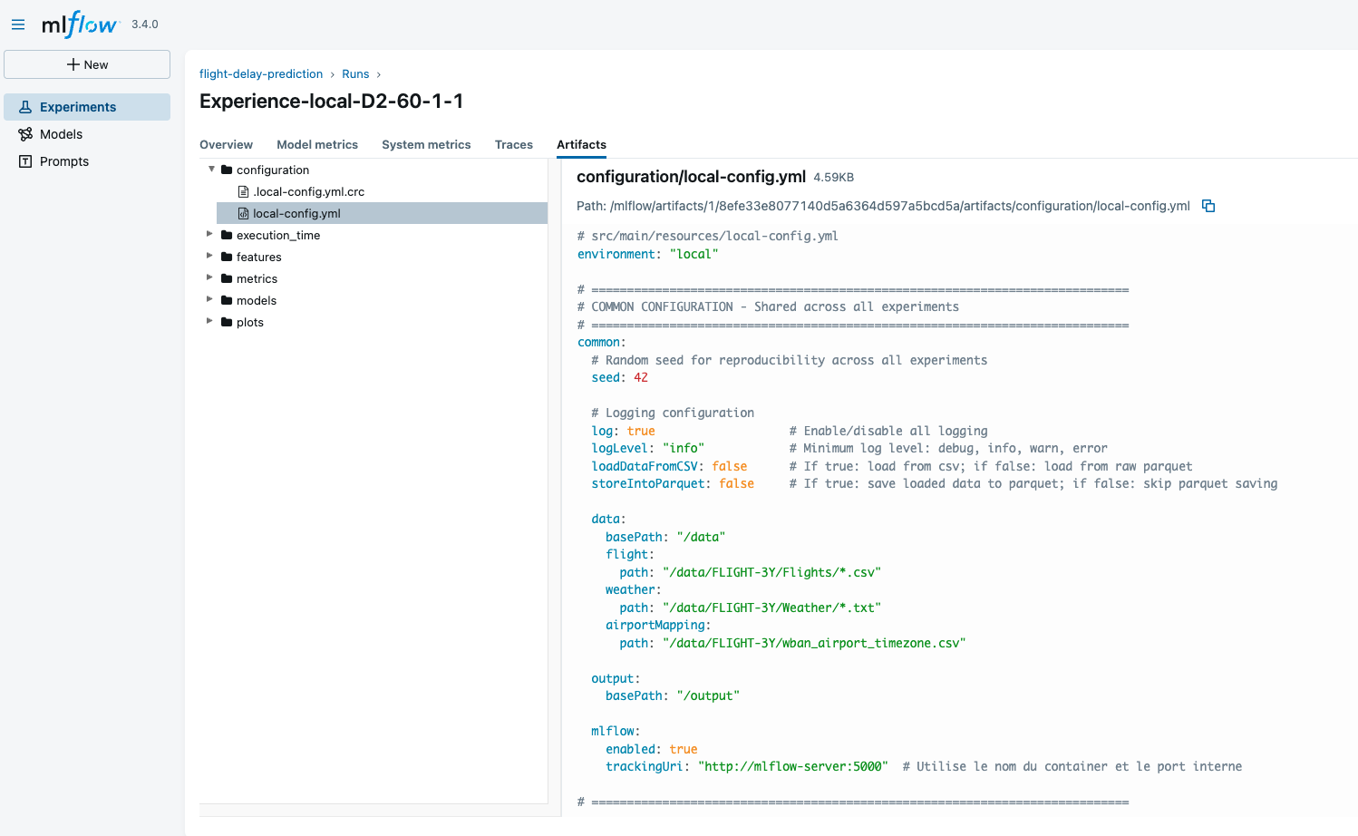
Logging these parameters is the first and most crucial step toward ensuring perfect reproducibility. With this information, we can trace any result back to the precise set of configurations that produced it, allowing us to recreate the experiment at any time.

4.2 Performance Metrics
We track two distinct but equally important categories of metrics: the predictive performance of our machine learning models and the computational performance of the underlying Spark pipeline.

4.2.1 Model Evaluation Metrics
Using the logModelMetrics and logMetric functions, we capture the final evaluation results of our trained models. This allows for direct, quantitative comparison between different models and hyperparameter sets.
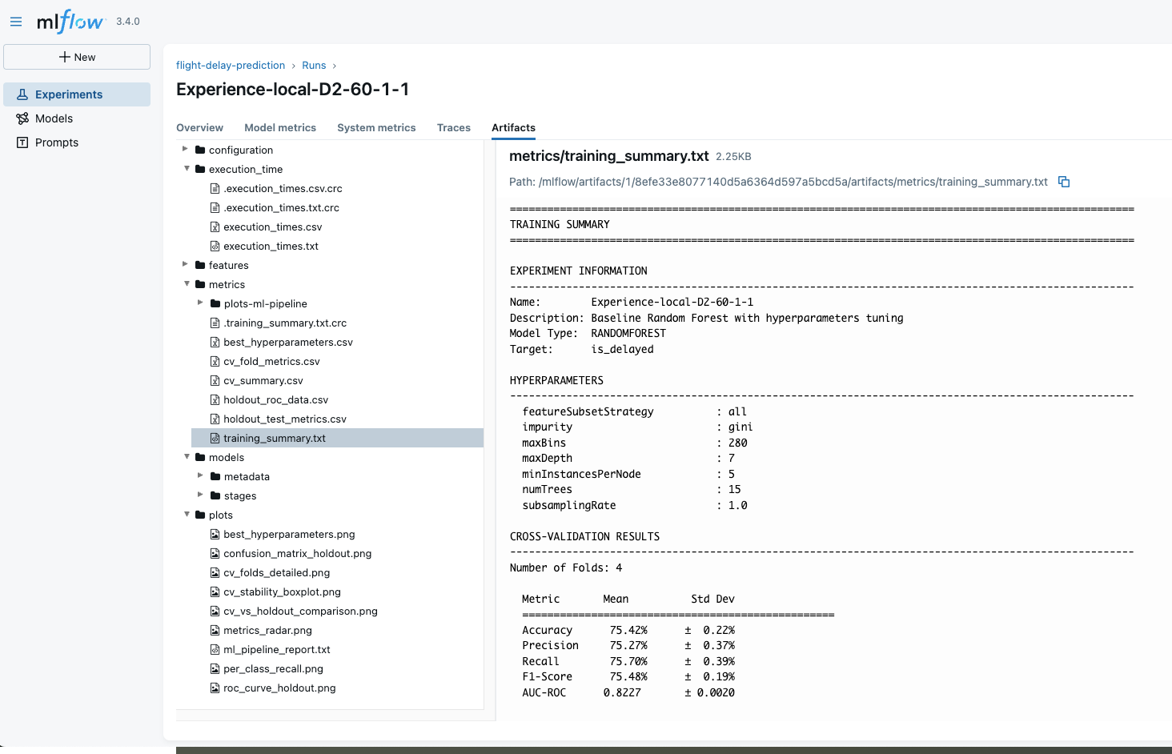
The key model performance metrics we log include:
- f1 score: The primary metric for our classification task, as defined in our experiment configuration.
- accuracy: A secondary metric providing an overall measure of correctness.
These metrics are logged for both the validation and test datasets, providing a clear picture of the model's ability to generalize to unseen data.

4.2.2 Spark Job Execution Metrics
Beyond model accuracy, we meticulously track the computational performance of our data processing and training pipelines. While these metrics are sourced directly from the Spark UI, MLFlow provides the essential run-level context that links a specific performance profile to a unique set of parameters, code, and data. This makes it straightforward to diagnose performance regressions and identify computational bottlenecks.
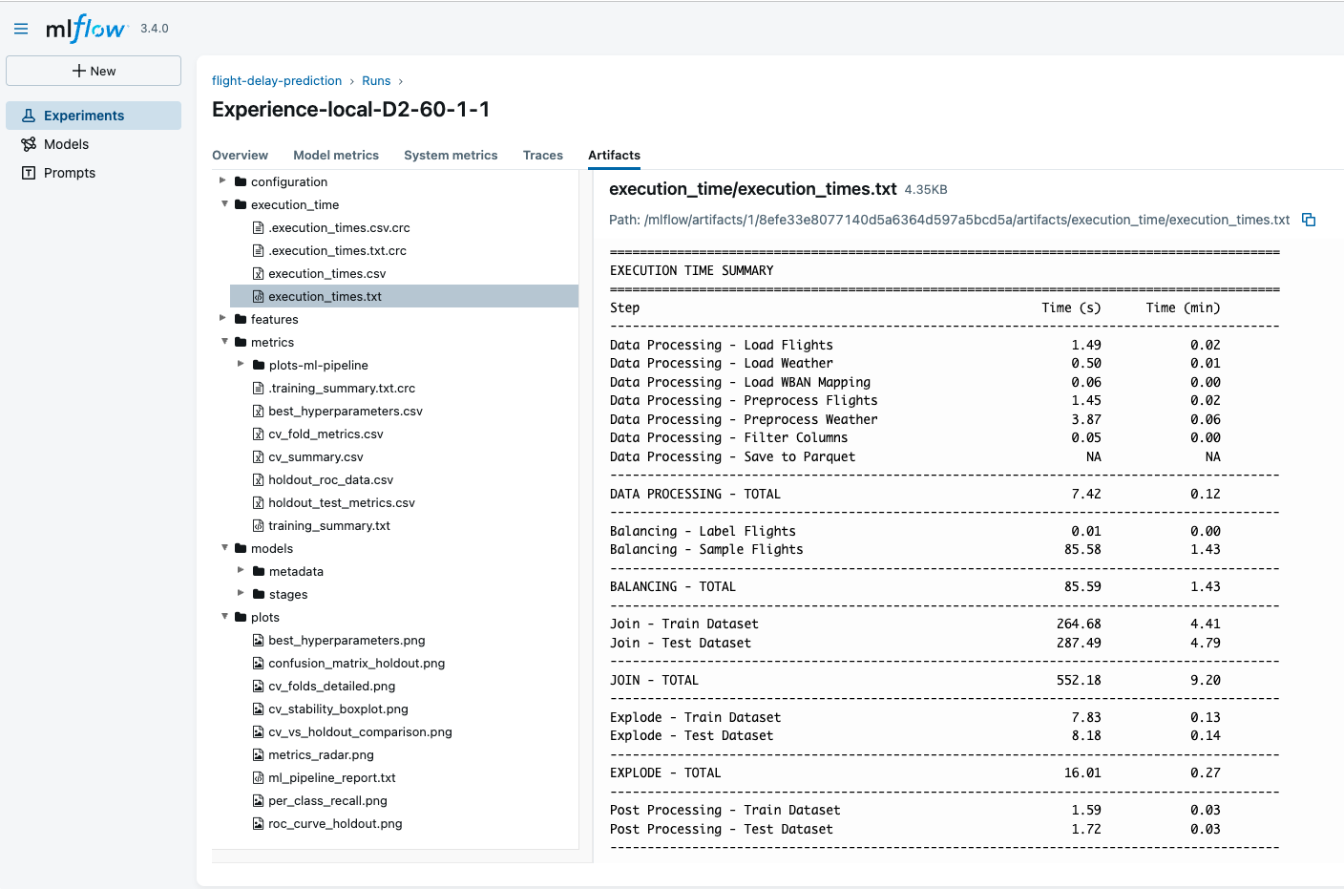

Key execution metrics we monitor include:
- Job and Stage Durations: Total time taken for key pipeline stages (e.g., Duration: 1.9 min for a feature engineering job like Job 93, up to 2.0 min for a complex join operation like Job 92).
- Data I/O: The volume of data read from and written to storage (e.g., Input: 161.1 MiB, Output: 17.2 MiB).
- Shuffle Performance: The size and record count of data shuffled between Spark executors, a critical indicator of distributed performance (e.g., Shuffle Read Size / Records: 639.7 MiB / 32631312).
- Resource Utilization: The memory consumed by Spark tasks during execution (e.g., Peak Execution Memory: 64.2 MiB).

4.3 Stored Artifacts
Artifacts are the tangible outputs of an experiment run. Using functions like logArtifact, logModel, and logPipelineModel, we store critical files such as trained models, datasets, and visualizations, making them permanent and easily accessible.

4.3.1 Trained Models and Pipelines
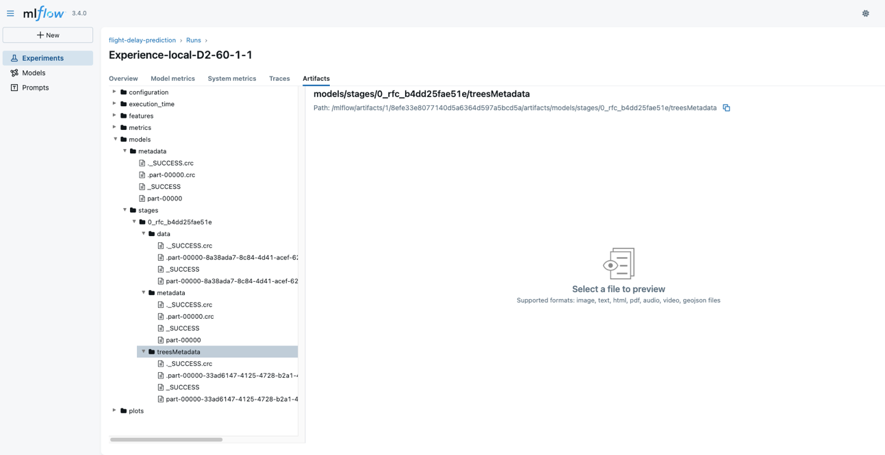
The most critical artifact we store is the fully trained Spark PipelineModel. This object encapsulates the entire workflow, including all preprocessing stages (e.g., string indexing, vector assembly) and the final trained classification model. By saving this complete pipeline to the MLFlow artifact store for each run, we ensure that we can retrieve and deploy the exact model that produced a given set of metrics, guaranteeing end-to-end integrity from training to production. Saving the PipelineModel instead of just the final classifier is a critical design choice. It captures not only the trained model but also the exact state of all feature transformers (e.g., StringIndexers, VectorAssembler) fitted on the training data. This guarantees that the exact same preprocessing logic is applied during inference, eliminating a common source of training-serving skew.

4.3.2 Datasets and Feature Importance
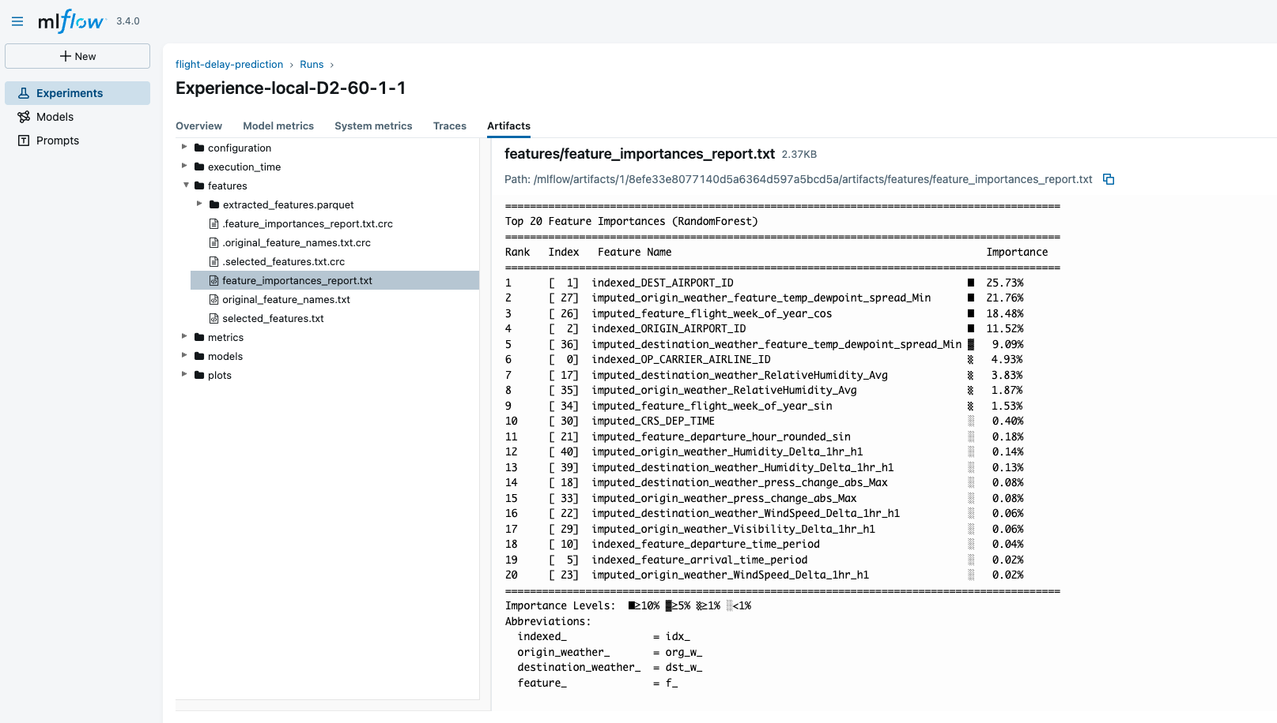
To maintain a clear audit trail and enhance model interpretability, we use our logDataset and logFeatureImportances functions. We log metadata about the datasets used in each run, including their storage paths and row counts, which provides a clear view of data lineage. Additionally, we calculate and log the feature importance scores from our models, helping us understand which factors are most influential in predicting flight delays.

4.3.3 Generated Visualizations
Our custom Spark Docker image (Dockerfile.spark-mlflow) comes pre-installed with matplotlib and seaborn. This setup enables our Spark applications to generate and save critical visualizations as .png image artifacts directly to MLFlow. These artifacts provide quick, easily digestible summaries of model performance and behavior, such as:
- Feature importance plots
- Confusion matrices
- ROC curves
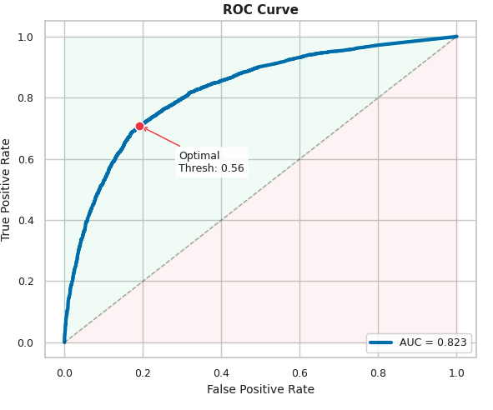 | 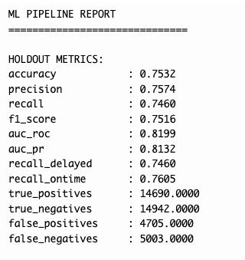
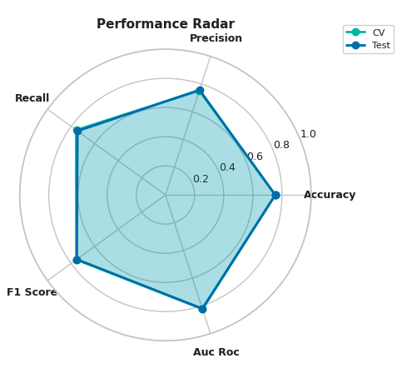 | 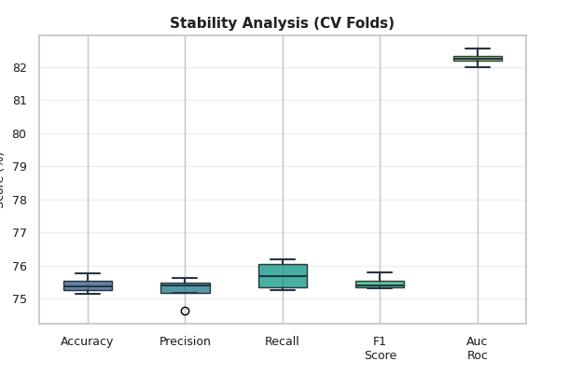

By enriching each run with these visual summaries, we make the experimental results more accessible and easier to interpret for the entire team. This comprehensive approach to tracking delivers significant benefits to our development lifecycle.
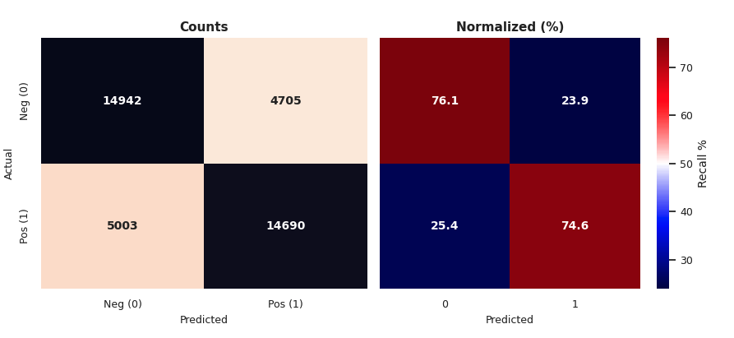
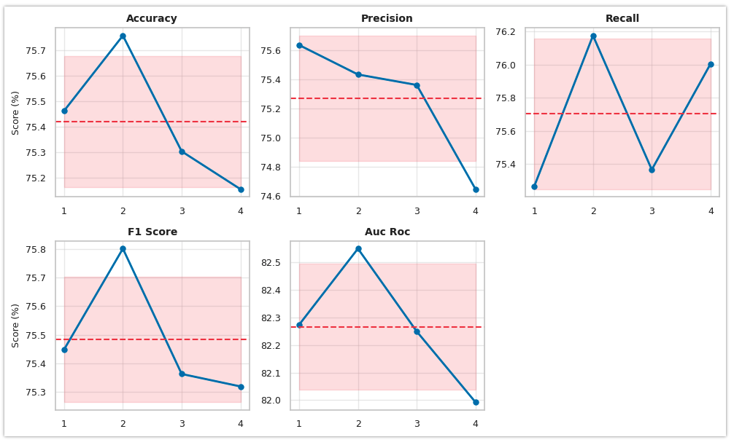
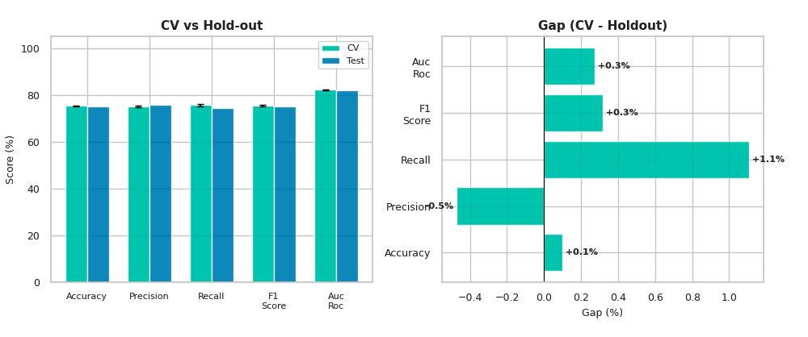

5.0 Conclusion: The Value of Systematic Experiment Tracking
By integrating MLFlow into our Spark-based workflow and adopting a standardized tracking methodology, we have established a robust and scalable foundation for our machine learning development. This systematic approach transforms our process from a series of isolated tasks into a fully traceable and reproducible science, delivering significant strategic advantages. The value of this integration is distilled into several key benefits:
- Full Reproducibility: Every result is automatically linked to its exact code, data, and configuration. This eliminates ambiguity and allows any experiment to be perfectly recreated, which is essential for debugging, validation, and regulatory compliance.
- Accelerated Development: The centralized MLFlow UI enables rapid, side-by-side comparison of dozens of experiments. This allows our team to quickly identify the most promising models, feature sets, and hyperparameters, significantly shortening the development cycle.
- Enhanced Collaboration: MLFlow serves as a central, shared repository for all experimental results, providing a single source of truth for the entire team. This shared context eliminates silos and ensures that all team members are working with the same information when making decisions.
- Foundation for CI/CD for ML: This robust tracking system is the prerequisite for automation. The metadata logged for each run enables a CI/CD pipeline to programmatically query the MLFlow API for the run with the highest validation_f1 score, retrieve its associated PipelineModel artifact, and automatically trigger a deployment job, turning our research into a production-ready asset with minimal human intervention.

